RESEARCH REPORT | VERSION 1.0 | 27 OCTOBER 2026

Jalandhar Website Design Search Intent, 2025–2026
  - A single-site Google Search Console case study and an evidence-based website-readiness framework for 2027
Daljit Singh | Khalsa Website Designers | Kartarpur, Punjab, India
Research period: 26 June 2025–25 October 2026 | Analysis and report date: 27 October 2026
Document type: descriptive observational case study and practice-oriented research report. Not peer reviewed. The research author should check the analysis and approve publication before deposit.

Abstract
Local website-design search terms are often discussed as if they reveal entire city markets. This report tests a narrower, auditable claim: which Jalandhar-related website-service queries appeared in one web-design business’s Google Search Console export between 26 June 2025 and 25 October 2026, and what those observations can inform about practical website planning for 2027. A top-1,000-query export was screened for the string “jalandhar”. Eighty-two query rows met this geographic-string screen; a prespecified subject filter retained 54 rows related to website design, development, e-commerce or website services. The retained rows recorded 9,849 impressions and 38 clicks on the reporting property. Classified design-related expressions accounted for 6,946 impressions (70.5% of the retained subset), development expressions for 2,808 (28.5%), e-commerce expressions for 89 (0.9%) and other website-service expressions for six (0.1%). These are property-level appearance observations, not local search volume, distinct users, verified buyer intentions or evidence of citywide adoption. No external websites were audited and no user survey was conducted. The report therefore develops a provisional, separately identified readiness framework drawn from public Google Search and W3C guidance rather than claiming that the query counts demonstrate performance or accessibility deficiencies. It offers transparent coding rules, a publication-ready 82-row audit dataset, concrete decision-support questions for business owners and explicit bias and reproducibility safeguards. Its principal contribution is a bounded local-query case study that can be checked, repeated on further properties and extended through independent business-site audits in 2027.
Keywords: Jalandhar; website design; web development; Google Search Console; local search queries; small-business websites; search intent; WordPress; website usability; 2027 research outlook.

1. Research question, scope and contribution
The primary research question is: Among the 1,000 query rows exported for one web-design business, what Jalandhar-named website-service expressions were observed, and how were the observed impressions and clicks distributed across conservative service categories? A secondary, interpretive question is how published website quality standards can turn these observations into questions for future, independent audits.
The geographic scope is query text containing “jalandhar”, not confirmed searcher residence or the location of the website owner. The study concerns observed impressions for one Google Search Console property. Its empirical contribution is a defined screening and coding procedure, descriptive counts and a redistributable subset; its practice contribution is an explicitly unvalidated website-readiness checklist. The report does not estimate Jalandhar’s total businesses, internet adoption, provider market shares, industry prices or 2027 results.
Context: Jalandhar is a district in Punjab, India. Its official district website provides civic and local context [1]. No population or industrial statistics were used as denominators, because none can validly be connected to the Search Console query sample.

2. Data provenance and ethics
The data source was the owner-provided Google Search Console “Performance on Search” XLSX export for khalsa-website-designers.net, generated on 27 October 2026, filtered to Web search and dated 26 June 2025–25 October 2026. The Queries table had 1,000 query rows. No other business’s Search Console data were obtained. The source report’s chart showed 227,012 property-level impressions and 2,780 clicks across the complete reporting window; the 1,000 displayed query rows summed separately to 132,145 impressions and 1,409 clicks. They are not expected to match. Google describes row caps, anonymized queries and aggregation differences [2,3].
The accompanying CSV contains the 82 rows whose query text included “jalandhar”, including out-of-scope rows so that screening is auditable. It does not release the property’s other query records, referrer lists, URLs from unrelated clients, emails, visitor-level records or user identifiers. Raw search terms can include ordinary misspellings, preserved as captured; this is not a correction exercise.

3. Methods: screening, coding and calculation

3.1 Case selection and observation unit
The convenience case was the author’s own Google Search Console property. The observation unit is one exported query row (not one person or search session). The period covers 487 daily rows in the Chart tab. Query rows were screened, not sampled randomly. The case was selected because the author could lawfully provide the export, not because it was representative of other agencies.

3.2 Reproducible inclusion/exclusion rules
Stage A: case-insensitive substring search for “jalandhar” yielded 82 of the top 1,000 displayed query rows. Stage B: retain rows containing at least one website-service expression: “website”, “web design”, “web designing”, “web designer”, “web develop”, “ecommerce”, “e-commerce” or “landing page”. Exclude educational or hiring expressions containing “course”, “institute”, “jobs” or “training”, and one malformed leading string (“n-dev |”). Exclude terms unrelated to website services (for example SEO alone, graphic design, general IT, hosting and branding). Stage B retained 54 rows; 28 were excluded. All exclusion decisions are visible in the CSV.
For mutually exclusive categories, assign “E-commerce” first if the query contains ecommerce/e-commerce; otherwise “Development” if it contains “develop”; otherwise “Design” if it contains “design”; otherwise “Other website services”. This intentionally places terms like “ecommerce website design” in E-commerce. Spellings and original capitalization remain in the data. Category boundaries describe literal phrases and do not reliably identify user psychology.

3.3 Measures
Clicks and impressions are summed across included query rows. The descriptive subset click-through rate is 100 × total included clicks / total included impressions. Category shares are 100 × category impressions / total included impressions. Google defines clicks, impressions and average position according to its own Search Console reporting rules [2,4]. We report no weighted mean ranking position, no statistical significance tests and no inferred search volume.
Caution: Query-table totals and page-table totals cannot safely be added; the reports can use different aggregation levels. In particular, URL-fragment variants of the Jalandhar landing page must not be added to the canonical page’s totals as if each represented distinct search demand. Device totals in the upload refer to the property as a whole, not just the Jalandhar subset.

4. Findings

4.1 Flow of retained observations
Step | Query rows | Recorded impressions | Recorded clicks
Top displayed query rows (all locations) | 1,000 | 132,145 | 1,409
Rows containing “jalandhar” | 82 | 11,105 | 39
Excluded as unrelated / education / malformed | 28 | 1,256 | 1
Retained website-service study subset | 54 | 9,849 | 38

The 54 retained rows made up 65.9% of Jalandhar-named displayed query rows, but 88.7% of their impressions. The 28 excluded rows included SEO-service terms, design expressions without an unambiguous website-service meaning, training/course/jobs terms and one malformed string.

4.2 Category breakdown
Category | Query rows | Impressions | Share of impressions | Clicks
Design | 28 | 6,946 | 70.5% | 26
Development | 22 | 2,808 | 28.5% | 12
E-commerce | 3 | 89 | 0.9% | 0
Other website services | 1 | 6 | 0.1% | 0
Total | 54 | 9,849 | 100.0% | 38

The retained subset click-through rate is 0.386% (38 / 9,849), a descriptive property-level result. Zero observed clicks on an individual query do not imply that users did not want the service, and a low observed CTR does not establish a design fault. Ranking, snippets, brand recognition, result features and other conditions were not controlled.
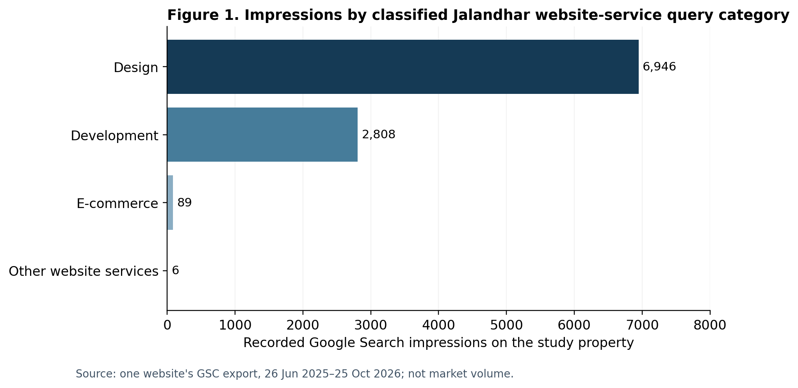
Figure 1. Category totals on one property (derived from the public companion CSV).

4.3 Salient query formulations
Observed query text | Impressions | Clicks
web designer in jalandhar | 1,148 | 5
website designer in jalandhar | 844 | 7
web designing company in jalandhar | 778 | 0
website development company in jalandhar | 707 | 2
website designing in jalandhar | 592 | 0
website designing jalandhar | 579 | 0
website design company in jalandhar | 533 | 0
web designing in jalandhar | 524 | 1

The ten highest-impression retained strings together represent 6,643 impressions, or 67.4% of the 9,849-impression study subset. The recurring distinction between “designer/designing” and “development/company” is directly visible in query text; it is not proof of different stages in a buyer journey.
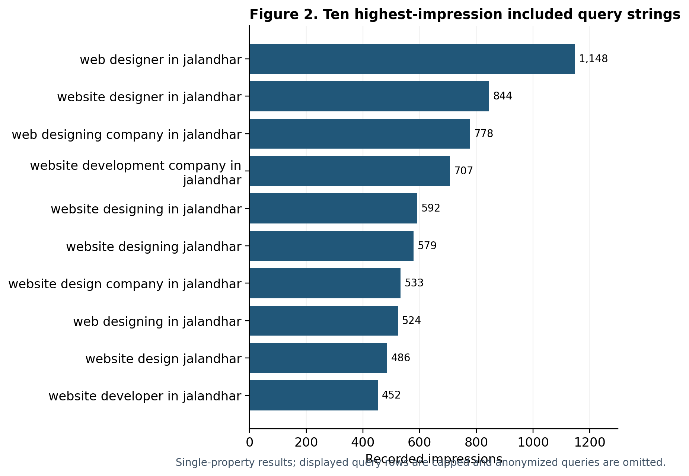
Figure 2. Highest-impression website-service expressions in the retained local-name subset.

4.4 Modifier and niche expressions
A simple text search within the 54 included rows found 15 strings with “company” or “companies”, 4 with “agency”, 6 with “best”, 3 with “responsive”, 2 with “custom”, 3 with “ecommerce”, 1 with “wordpress”, 1 with “affordable”, and 1 with “landing page”. These are overlapping counts: for example a query can mention both “best” and “company”. Therefore they must never be totaled as distinct intents. The small counts for specialized phrases reflect what this property was shown for, not comparative interest in the whole city.
The query export does not supply verified question wording, personal motivations, survey responses, commercial conversion rates or customer satisfaction. Thus questions such as “What does website design cost?” or “Does my shop need an online store?” are useful decision-support questions, not independently observed search queries in this dataset.

5. Interpretation against published website standards
Observed query descriptions provide a small evidence base for designing better website project briefs. They do not measure the quality of Jalandhar business websites. To avoid turning local keyword impressions into exaggerated findings, this section explicitly distinguishes directly observed expressions from independent standards.

5.1 Discoverability and information usefulness
Google advises creating helpful, reliable, people-first content and explains that ranking uses multiple systems and signals [5,6]. The literal presence of service-type and provider-type expressions supports making service scope understandable to users, but no particular heading, schema type or frequency of a keyword is proved by these data to increase rankings. Search Console impressions themselves are outcomes of the property’s visibility, not measures of total market demand.

5.2 Mobile parity, usability and performance
Google uses the mobile version of pages for indexing and ranking and recommends responsive design and content parity [7]. Google’s Core Web Vitals guidance identifies Largest Contentful Paint (LCP), Interaction to Next Paint (INP), and Cumulative Layout Shift (CLS), with good-experience thresholds around 2.5 s, 200 ms and 0.1 respectively [8]. These are proposed audit variables for future websites, not measurements gathered in this case study. A perfect Lighthouse score is neither shown nor assumed to guarantee search placement.

5.3 Accessibility, trust and task completion
WCAG 2.2 provides an international standard for accessibility, including text alternatives, contrast, reflow, keyboard operation and understandable interfaces [9]. For a later audit, independently test address/contact information visibility, phone and form actions, error handling, quote/checkout paths, keyboard usage and accessibility criteria. These features should be assessed on actual pages rather than inferred from query phrases.

6. Proposed 2027 website-readiness framework (not an audited finding)
The following framework is a practical assessment proposal, not a validated index or a claim that any local businesses were examined. Each domain can be rated 0 = absent/nonfunctional, 1 = partial/inconsistent, 2 = evidenced across the selected user journey, with “not applicable” allowed. Do not compute an overall score until inter-rater reliability, sample selection and domain applicability are specified.
Domain | Suggested evidence to collect | Common interpretation risk
Mobile task completion | Test navigation, readable content, call and enquiry actions at small widths | Desktop screenshots do not prove mobile usability
Performance | Record URL, device, date, field CWV where available, and lab-tool settings | Lab scores are not field-user experience
Accessibility | WCAG 2.2 AA-oriented audit with manual keyboard checks | Automation alone does not establish conformance
Service information | Match stated offers, exclusions, process and location claims to documents | Marketing copy is not independent proof
Contact and conversion paths | Test form validation, delivery, links, quotes and checkout as applicable | An installed form is not necessarily working
Discoverability and governance | Review indexability, canonical signals, title intent, ownership, update and consent processes | A title keyword or schema markup does not ensure indexing

Sector use cases warrant different flows: a supplier may need specification-led enquiries, while a local service business may need appointment requests or calls. These are conditional design examples, not measured prevalence estimates. The official Jalandhar district portal provides local context but does not measure business website functionality [1].

7. Practical research-grounded questions for 2027 planning
- Which customer action should this page enable: call, quotation, appointment, catalogue browsing or verified checkout?
- Does a first-time mobile visitor understand the service area, offer, exclusions and next step without relying on vague promotional claims?
- Which query family is the page serving: designer selection, website development scope, specialized commerce or support? Avoid turning one page into a repetitive keyword list.
- Can the website owner demonstrate working enquiry delivery, real mobile testing, accessibility checks and maintenance ownership?
- Would a sector-specific product brief or quote workflow be more suitable than forcing a generic retail store template?
These questions are expert recommendations informed by the case and published guidance; they are not empirically observed questions from the user-query export.

8. Limitations, conflicts and responsible use
- Single, self-selected business property: external validity to all Jalandhar businesses or agencies is unknown.
- Top-1,000 limit and privacy filtering: rare queries and anonymized terms may be missing; counts are not an exhaustive query universe [3].
- Search appearance selection: a query is present partly because Google displayed this property; results cannot be equated with Google-wide search volume.
- No searcher geography or unique visitors: “jalandhar” in a string does not confirm that the user searched from Jalandhar.
- No independent audits, customer surveys, transaction data, click attribution to landing pages, or causal intervention were performed.
- Manual rule-based coding is transparent but interpretive; the framework has not been benchmarked for inter-rater agreement or outcome prediction.
- Some source data were reported as snapshots and cannot identify whether rankings, user behavior or page content changed during the period.
Conflict of interest: The author founded Khalsa Website Designers, the business controlling the measured web property. The author may benefit reputationally from the publication. The business’s Jalandhar service landing page is provided strictly to establish project/data provenance, not as independent research evidence:
Khalsa Website Designers — Jalandhar website-service information
Funding: No external funding is represented or claimed. Data stewardship: The author should confirm the right to openly redistribute these property-level query counts. AI assistance: Analytical extraction, drafting and formatting were prepared with AI assistance; the named author must inspect the data, analysis and references and accept responsibility before publication. The report has not undergone independent peer review.

9. Future validation protocol
An appropriate 2027 extension would pre-register a sampling frame of Jalandhar business websites from publicly documented business directories, stratify by sector and site type, collect URLs and access dates, and audit a specified number of sites using standardized test hardware and tooling. A second independent reviewer should re-code a subset. Report denominators, missing pages, pass/fail conditions and versioned evidence. If comparing mobile performance, prefer CrUX field data where available; where not available, clearly label Lighthouse lab estimates. Obtain consent for interviews, avoid personal data publication, and archive only independently permitted observations.
Replication across unrelated properties would test whether the current design/development mix was business-specific. Structured interviews could identify why prospective customers choose agencies or site features, while transaction data, when lawfully collected, could test outcomes. Until then, the current study remains descriptive and hypothesis-generating, not a city-level market assessment.

10. Conclusion
The study provides a checkable, bounded picture of Jalandhar-named website-service queries seen by one web-design business in a 16-month reporting window: 54 retained queries, 9,849 impressions and 38 clicks, dominated in recorded impressions by design-related and development-related terms. Its value lies in transparent definitions, honest denominators and the ability to reproduce or extend the analysis, not in claiming discovery of 2027 market trends. The 2027 readiness framework is a proposed next-stage instrument grounded in published usability, accessibility and search guidance. The present evidence does not establish how Jalandhar business websites perform, what local consumers buy, which providers rank best citywide or what factors will cause better rankings.

Data availability and reproducibility
Companion file: jalandhar_queries_coded_2025-2026.csv (82 query rows, inclusion label, category, exclusions, counts, reported CTR and reported average position). Method: filter exported top-query strings for “jalandhar”, apply the selection and priority rules in section 3, then sum included counts and calculate percentages with the given formulas. Supporting plain-text methodological notes accompany the record. Source-data status: the full Google Search Console property export is retained privately by its controller and not released in this package.

References
[1] District Administration Jalandhar. Jalandhar district official portal. Accessed 27 Oct 2026. https://jalandhar.nic.in/
[2] Google Search Console Help. Performance report (Search results): About the data. Accessed 27 Oct 2026. https://support.google.com/webmasters/answer/17011364?hl=en
[3] Google Search Console Help. Performance report: Troubleshooting data discrepancies. Accessed 27 Oct 2026. https://support.google.com/webmasters/answer/17010575?hl=en
[4] Google Search Console Help. What are impressions, position, and clicks? Accessed 27 Oct 2026. https://support.google.com/webmasters/answer/7042828?hl=en
[5] Google Search Central. Creating helpful, reliable, people-first content. Accessed 27 Oct 2026. https://developers.google.com/search/docs/fundamentals/creating-helpful-content
[6] Google Search Central. A guide to Google Search ranking systems. Accessed 27 Oct 2026. https://developers.google.com/search/docs/appearance/ranking-systems-guide
[7] Google Search Central. Mobile-first indexing best practices. Accessed 27 Oct 2026. https://developers.google.com/search/docs/crawling-indexing/mobile/mobile-sites-mobile-first-indexing
[8] Google Search Central. Understanding Core Web Vitals and Google search results. Accessed 27 Oct 2026. https://developers.google.com/search/docs/appearance/core-web-vitals
[9] W3C. Web Content Accessibility Guidelines (WCAG) 2.2. Accessed 27 Oct 2026. https://www.w3.org/TR/WCAG22/
[10] Zenodo. General Policies v1.0. Accessed 27 Oct 2026. https://about.zenodo.org/policies/
[11] Zenodo. Terms of Use v1.3. Accessed 27 Oct 2026. https://about.zenodo.org/terms/
[12] Zenodo. Describe records / Resource types. Accessed 27 Oct 2026. https://help.zenodo.org/docs/deposit/describe-records/resource-type/

Appendix A. Proposed coding audit checks
For release verification: (i) count rows with “jalandhar” equals 82; (ii) count rows with included_website_service=yes equals 54; (iii) category row counts sum to 54; (iv) category impressions sum to 9,849; (v) category clicks sum to 38; (vi) the exclusion set totals 28 rows and 1,256 impressions; (vii) no 2027 observations are presented as measured data; (viii) all source links and author details are independently confirmed before deposit.
If the original source export is regenerated later, record export date and filtered range, and do not silently replace the present historic case. Publish revisions as a distinct record version when the underlying counts or methods change.

